Kendriya Vidyalaya No.2, Kasaragod
Celebration of River Festival 2021 from 17th to 23rd December 2021
The ecoclub members of class VIII and three teachers have visited the river Madhuvahini in Chengala Panchayath on 22/12/2021. A local environmentalist, P K Prabhakaran interacted with the students during the nature walk through the half dried Madhuvahini river. The river study group has got a real picture of over exploitation and pollution of Madhuvahini river. The environmentalist has shown ‘wells’ constructed inside the river for irrigation.
The nature walk through the river was a new experience for the students and teachers.

Talk by an environmentalist on river ecosystem in Madhuvahini River.
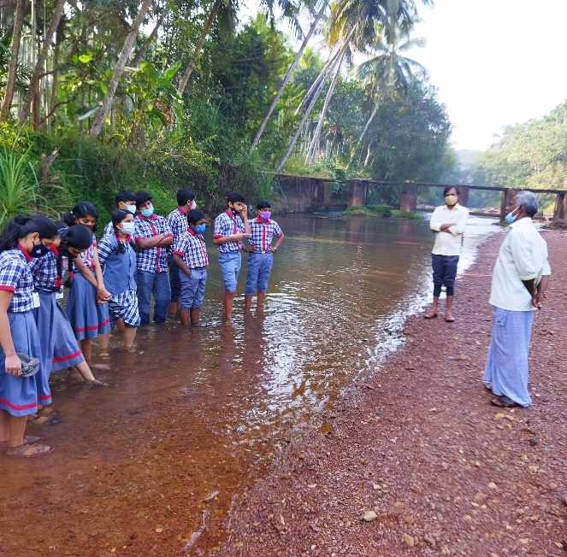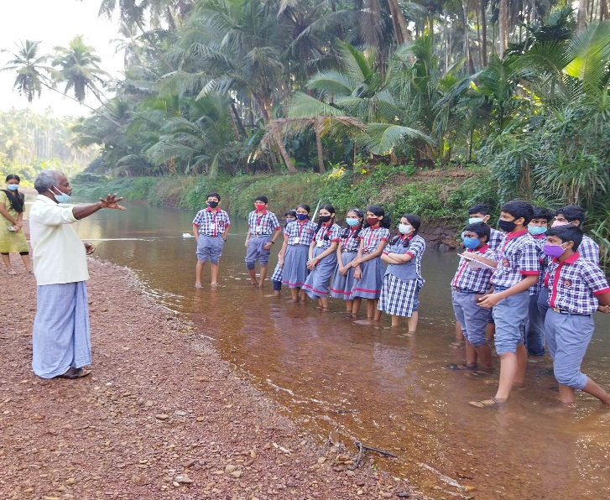

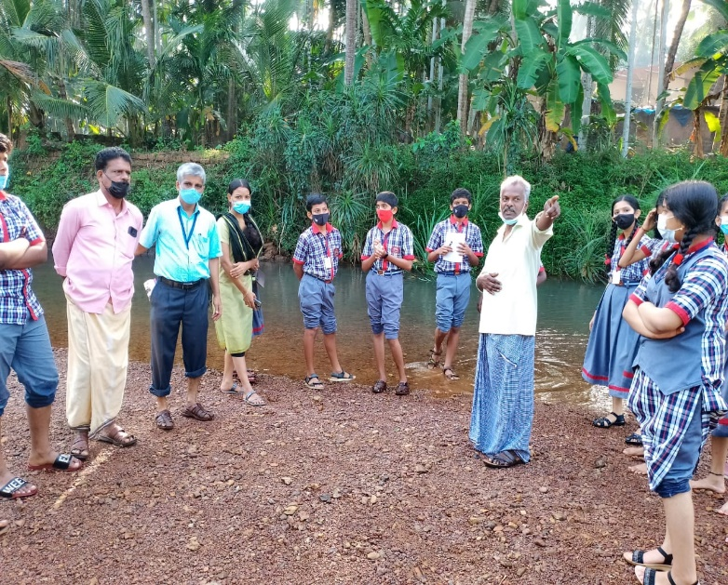

Cleanliness campaign in Madhuvahini river
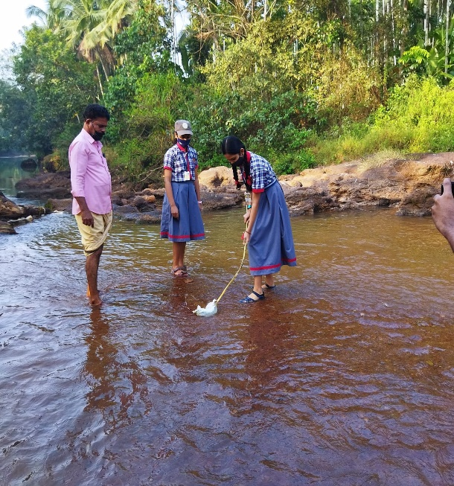

Nature walk through Madhuvahini river.




