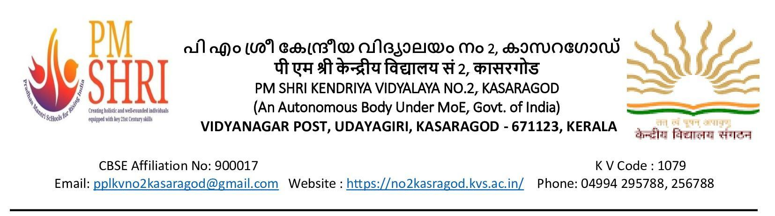 F.No.1079/KV2KSD/2023-24 दिनांक/Date: 29.01.2024

प्रत्यक्षसाक्षात्कार / WALK IN INTERVIEW
पी एम श्री केंद्रीय विद्यालय नंबर 2 कासरगोड में निम्नलिखित क्रमानुसार संविदा शिक्षक/ शिक्षिकाओं की नियुक्तिके लिए प्रत्यक्षसाक्षात्कारका आयोजन कियाजाएगा | नियुक्तिरिक्तपदोंकेअनुसारहोगी | योग्यता केन्द्रीय विद्यालय संगठन के मानदंडों के अनुरूप है |
Walk-in Interview for Contractual appointment against the following posts will be conducted in PM Shri Kendriya Vidyalaya No.2, Kasaragod as per the following schedule. Offer of appointment will be subject to availability of vacancy and required qualification as per KVS norms.

तिथि /Date | पद / Post | शैक्षिकयोग्यता / Educational Qualification
02/02/2024 | पीजीटी (गणित, हिंदी, वाणिज्य) /  PGT ( Maths, Hindi, Commerce) | 1. Two years‟ Integrated  Post Graduate M.Sc. Course of Regional College of Education of NCERT in the  concerned subject;  OR  Master Degree from a recognized University with at least 50% marks in aggregate in the following subjects:  a) PGT (Maths) Mathematics/ Applied Mathematics  b)PGT (Hindi) – Hindi or Sanskrit with Hindi as one of the subjects at Graduate level.  c) PGT(Commerce) - Master’s Degree in commerce. However holder of Degree of M.Com in applied/ Business Economics shall not be eligible.  2. B.Ed. or equivalent degree from recognized university  3. Proficiency in teaching in Hindi and English media.
 | टीजीटी (विज्ञान, सामाजिक विज्ञान) /  TGT (Science, Social , Science) | Bachelor’s Degree with atleast 50% marks in the concerned subjects/combination of subjects and in aggregate.  B.Ed or equivalent degree from a recognized university.  TGT (Science, Social - Any two of the following: History, Geography, Economics, & Pol. Science of which one must be either History or Geography  TGT(Science) - Botany, Zoology & Chemistry  Candidates with CTET-part II qualification may be given priority.
 | बालवाटिका शिक्षक / Balvatika Teacher | i. Senior Secondary Class (Class XII or its equivalent) from a recognized Board with at least 50% marks and  ii. Diploma in nursery Teacher education/ Pre-school Education/Early Childhood Education Programme (D.E.C.Ed) of duration of not less than two years orB.Ed (Nursery) from NCTE recognized institution.
03/02/2024 | कला अध्यापक / Art Teacher | Degree/Diploma in Art/Craft with proficiency, experience and ability to communicate in English/Hindi.
 | प्राथमिक अध्यापक / Primary Teacher | Essential:  i) Senior Secondary School Certificate with 50% marks or  Intermediate with 50% marks or its equivalent and  ii) Diploma of Certificate in basic teachers’ training of duration of not less than two years or B.El.Ed.  iii) Pass in Central Teacher Eligibility Test (CTET) Paper – I, conducted by the CBSE in accordance with the Guidelines framed by the NCTE for the purpose.  iv) Competence to teach through Hindi & English media.  Desirable: Knowledge of Computer Applications.
 | संगीत शिक्षक /  Music Teacher | Essential:  1. Senior Secondary School Certificate with 50% marks or Intermediate with 50% marks or its equivalent and Bachelor Degree in Music or equivalent from a recognized University.  2. Competence to teach through English/Hindi media.  Desirable : Knowledge of computer application.
 | कंप्यूटरप्रशिक्षक /  Computer Instructor | At-least 50% marks in aggregate in any of the following.  BE/B. Tech (Com. Sci.) /BCA /MCA/ M.Sc. (Electronics with Comp. Sci. component)/M.Sc. (IT)/B.Sc. (Comp. Sci.)  OR  Degree/PG (any subject)/ Mathematics with PGDCA from Govt. recognized institute.  OR  'B' Level from DOEACC and Post Graduate degree in any subject.  OR  'C' Level from ,DOEACC, Ministry of Information and Communication Technology and Graduation.  OR  Any PG with A Level DOEACC
 | योग प्रशिक्षक /  Yoga Instructor | Graduate in any discipline with degree/Diploma in Yoga from recognized university
 | मलयालमभाषाशिक्षक /  Malayalam Language Teacher. | Post Graduate in the concerned subject with at least 50% marks along with B.Ed.
 | विशेषशिक्षक /  Special Educator | Graduates with B.Ed (Special Education) or B.Ed with 2 years diploma with special education
 | परामर्शदाता /  Counselor | Degree (B.A/B.Sc (Psychology) with certificate of Diploma in counseling with a minimum of 1 year experience.  Desirable qualification required:  Minimum of one year experience in providing career/educational counseling to students at schools.  Or  Working knowledge and experience in placement bureaus.  Or  Registration with rehabilitation council of India as vocational counselor.
 | चिकित्सक /  Doctor | Doctor (Minimum MBBS and registered with MCI
 | स्टाफनर्स /  Staff Nurse | Diploma/Graduation in General Nursing  OR  B.Sc. Nursing.

