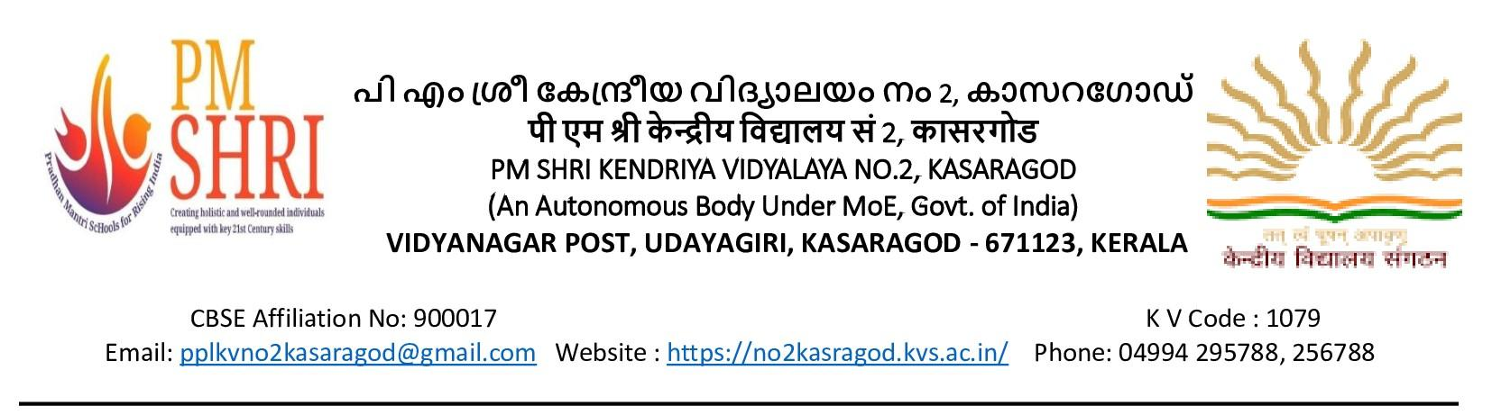 F.No.1079/KV2KSD/2023-24 Date: 27.01.2024

प्रत्यक्ष साक्षात्कार / WALK IN INTERVIEW
पी एम श्री केंद्रीय विद्यालय नंबर 2 कासरगोड में निम्नलिखित क्रमानुसार संविदा शिक्षक/शिक्षिकाओं की नियुक्ति के लिए प्रत्यक्ष साक्षात्कार का आयोजन किया जाएगा | नियुक्ति रिक्त पदों के अनुसार होगी | योग्यता केन्द्रीय विद्यालय संगठन के मानदंडों के अनुरूप है |
Walk-in Interview for Contractual appointment against the following posts will be conducted in PM Shri Kendriya Vidyalaya No.2, Kasaragod as per the following schedule. Offer of appointment will be subject to availability of vacancy and required qualification as per KVS norms.

तिथि / Date | पद / Post | शैक्षिक योग्यता / Educational Qualification
02/02/2024 | पीजीटी (गणित, हिंदी, वाणिज्य) /  PGT ( Maths, Hindi, Commerce) | Post Graduate in the concerned subject with at least 50% marks along with B.Ed.
 | टीजीटी (विज्ञान, सामाजिक विज्ञान) /  TGT (Science, Social Science) | Bachelor’s Degree in the concerned subject with at least 50% marks and B.Ed. (for TGT Social Science, History/Geography Economics and Political Science). Candidates with  CTET-part II qualification may be given priority.
 | बालवाटिका शिक्षक / Balvatika Teacher | i. Senior Secondary Class (Class XII or its equivalent) from a recognized Board with at least 50% marks and  ii. Diploma in nursery Teacher education/ Pre-school Education/Early Childhood Education Programme (D.E.C.Ed) of duration of not less than two years or B.Ed (Nursery) from NCTE recognized institutions.
03/02/2024 | कला अध्यापक / Art Teacher | Degree/Diploma in Art/Craft with proficiency, experience and ability to communicate in English/Hindi.
 | प्राथमिक अध्यापक / Primary Teacher | Senior Secondary (or its equivalent) with at least 50% marks and 2-year Diploma in Elementary Education (by whatever name known)  OR  Senior Secondary (or its equivalent) with at least 50% marks and 4-year Bachelor of Elementary Education (B.EL.Ed.)  OR  - Senior Secondary (or its equivalent) with at least 50% marks and 2- year Diploma in Education . OR Graduate with B.Ed. with at least 50% marks. A Six month Bridge course in Elementary Education recognized by the NCTE.  - Qualified in the Central Teacher Eligibility Test conducted by the Govt. of India. (C- TET-Level I- V). Proficiency to teach through Hindi & English medium  - Knowledge of working on Computer is compulsory.
 | संगीत शिक्षक /  Music Teacher | 1. Senior Secondary School Certificate with 50% marks or  Intermediate with 50% marks or its equivalent and Bachelor  Degree in Music or equivalent from a recognized University.  2. Competence to teach through English/Hindi media.  Desirable :  Knowledge of computer application.
 | कंप्यूटर प्रशिक्षक /  Computer Instructor | At-least 50% marks in aggregate in any of the following.  BE/B. Tech (Com. Sci.) /BCA /MCA/ M.Sc. (Electronics with Comp. Sci. component)/M.Sc. (IT)/B.Sc. (Comp. Sci.)  OR  Degree/PG (any subject)/ Mathematics with PGDCA from Govt. recognized institute.  OR  'B' Level from DOEACC and Post Graduate degree in any subject.  OR  'C' Level from ,DOEACC, Ministry of Information and Communication Technology and Graduation.  OR  Any PG with A Level DOEACC
 | योग प्रशिक्षक /  Yoga Instructor | Graduate in any discipline with degree/Diploma in Yoga from recognized university
 | मलयालम भाषा शिक्षक /  Malayalam Language Teacher. | Post Graduate in the concerned subject with at least 50% marks along with B.Ed.
 | विशेष शिक्षक /  Special Educator | Graduates with B.Ed (Special Education) or B.Ed with 2 years diploma with special education
 | परामर्शदाता /  Counselor | Degree (B.A/B.Sc (Psychology) with certificate of Diploma in counseling with a minimum of 1 year experience.
 | चिकित्सक /  Doctor | Doctor (Minimum MBBS and registered with MCI
 | स्टाफ नर्स /  Staff Nurse | Diploma/Graduation in General Nursing  OR  B.Sc. Nursing.

Instructions to the candidates for the above posts:
· Candidates should present themselves with all relevant certificates along with experience certificates, if any, original/self-attested copies for scrutiny/submission
· All the above vacancies as and when occur, are purely temporary and the selected candidates will not have any claim to be absorbed as regular employees.
· The appointment shall be till the regular employee joins duty or the contract period expires, whichever is earlier.
· Interview is to prepare a panel which will be operated for the year 2024-25 against any vacancy which may arise and being in the panel does not yield any right for appointment.
· No TA/DA will be paid for attending the Walk – in – Interview.
· Bio-data cum Declaration forms will be supplied to the candidates at the venue.

· उम्मीदवारों को अनुभव प्रमाण पत्र के साथ सभी प्रासंगिक प्रमाण पत्र, यदि कोई हो, मूल / स्व-सत्यापित प्रतियों को जांच / जमा करने के लिए प्रस्तुत करना होगा।
· उपरोक्त सभी रिक्तियां जैसे और जब होती हैं, पूरी तरह से अस्थायी होते हैं और चयनित उम्मीदवारों को नियमित कर्मचारियों के रूप में अवशोषित होने का कोई दावा नहीं होगा।
· नियुक्ति तब तक होगी जब तक नियमित कर्मचारी ड्यूटी में शामिल नहीं हो जाता या अनुबंध अवधि समाप्त नहीं हो जाती, जो भी पहले हो।
· साक्षात्कार का एक पैनल तैयार करना है, जो किसी भी रिक्ति के प्रतिकूल वर्ष 2024-25 के लिए संचालित किया जाएगा जो उत्पन्न हो सकता है और पैनल में होने से नियुक्ति के लिए कोई अधिकार प्राप्त नहीं होता है।
· वॉक-इन-इंटरव्यू में भाग लेने के लिए कोई टीए / डीए का भुगतान नहीं किया जाएगा।
· कार्यक्रम स्थल पर उम्मीदवारों को जैव-डेटा सह घोषणा पत्र दिए जाएंगे।

प्राचार्य / Principal

